

DLD Lab-06
Subtractor


NATIONAL UNIVERSTIY OF COMPUTER AND EMERGING SCIENCES, FAST- Peshawar Campus
Department Of Computer Science
EL1005 – Digital Logic Design-Lab
SEMESTER SPRING 2025

Contents
1. Objectives: 2
2. Equipment Required: 2
3. What is Subtractor ? 2
4. Half subtractor 2
5. FULL Subtractor 3
6. K-Map Minimization 4
7. Applications 5

Objectives:
To become familiar with the operation of adders and Subtractors

Equipment Required:
- DEV-2765E Trainer Board/ Multisim 14.2 /Logic.ly
- 7486 quad 2-input XOR gate IC
- 7404 Hex Inverter gate IC
- 7408 quad 2-input AND gate IC
- 7432 quad 2-input OR gate IC

What is Subtractor ?
Subtractor is an electronic logic circuit for calculating the difference between two binary numbers which provides the difference and borrow as output.

Half subtractor
Half Subtractor is used for subtracting one single bit binary number from another single bit binary number.It has two inputs; Minuend (A) and Subtrahend (B) and two outputs; Difference (D) and Borrow (Bout).
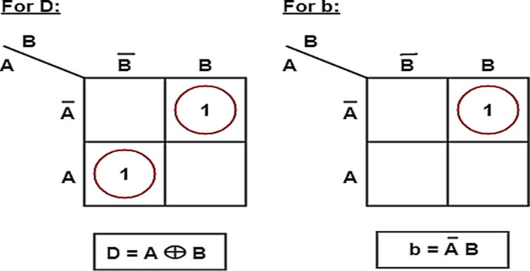
- Truth Table
Difference = A ⊕ B
Difference = A ⊕ B
Input |  | Output
A | B | Difference (D) | Borrow (B_{out})
0 | 0 | 0 | 0
0 | 1 | 1 | 1
1 | 0 | 1 | 0
1 | 1 | 0 | 0

From the truth table and K-map, the Boolean Expression can be derived as:
Difference (D) = A'.B + A.B'
A'.B + A.B' = A ⊕ B
Borrow (B_{out})= Ā.B

FULL Subtractor
A logic Circuit Which is used for subtracting three single bit binary numbers is known as Full Subtractor.
It has three inputs; Minuend (A), Subtrahend
(B) and following Subtrahend (C) and two outputs; Difference (D) and Borrow (B_{out}).
- Truth Table
Input |  |  | Output
A | B | B(in) | D | ^{B}(out)
0 | 0 | 0 | 0 | 0
0 | 0 | 1 | 1 | 1
0 | 1 | 0 | 1 | 1
0 | 1 | 1 | 0 | 1
1 | 0 | 0 | 1 | 0
1 | 0 | 1 | 0 | 0
1 | 1 | 0 | 0 | 0
1 | 1 | 1 | 1 | 1

- Solving Truth Table using K-Map
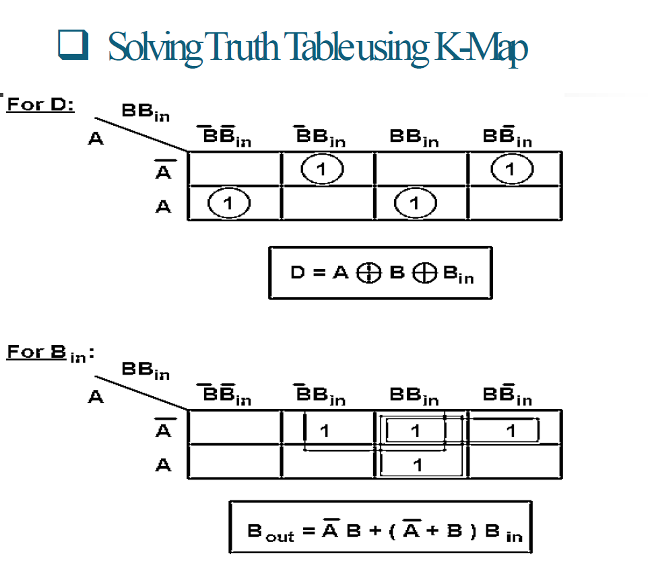

K-Map Minimization
From the Truth Table The Difference and Borrow will written as,
Difference=A'B'C+A'BC'+AB'C'+ABC
Reducing it we got, Difference=A ⊕B ⊕C

Borrow=A'B'C+A'BC'+A'BC+ABC
=A'B'C+A'BC'+A'BC+A'BC+A'BC+ABC
=A'C(B'+B)+A'B(C'+C)+BC(A'+A) Borrow=A'C+A'B+BC
From the truth table and k-map minimization, the Boolean Expression can be derived as:
D = A ⊕ B ⊕ C
B_{(out)} = BC + (B ⊕ C) A

Applications
- To attenuate the radio/audio signal
- In amplifier to reduce sound distortion
- In arithmetic logic unit of processors
- Increment and decrement operators
- Calculate addresses

Lab Task
- Design and implement the circuitry for a Half subtractor.
- Implement a half subtractor using AND, OR and NOT gates only.
- Implement a half subtractor using IC-74LS139.
- Design and implement the circuitry of a full subtractor.

